# **Week 7 – React Js Hands-On**

## **1. Hands-On1: (cricketapp)**

**FILENAME: ListofPlayers.js**

***import*** React ***from*** 'react';

***const*** ListofPlayers ***=*** () ***=>*** {

***const*** players ***=*** [

    { name: "Virat Kohli", score: *85*, country: "India" },

    { name: "Rohit Sharma", score: *55*, country: "India" },

    { name: "KL Rahul", score: *40*, country: "India" },

    { name: "Shreyas Iyer", score: *90*, country: "India" },

    { name: "Hardik Pandya", score: *70*, country: "India" },

    { name: "Rishabh Pant", score: *35*, country: "India" },

    { name: "Jasprit Bumrah", score: *88*, country: "India" },

    { name: "Ravindra Jadeja", score: *65*, country: "India" },

    { name: "David Warner", score: *75*, country: "Australia" },

    { name: "Joe Root", score: *60*, country: "England" },

    { name: "Kane Williamson", score: *78*, country: "New Zealand" }

  ];

***const*** below70 ***=*** players.filter(player ***=>*** player.score ***<*** *70*);

***return*** (

    <div>

      <h1>List of Players (Indian & International)</h1>

      <ul>

        {players.map((player, index) ***=>*** (

          <li key***=***{index}>

            {player.name} - {player.score}

            {player.country ***!==*** "India" ***&&*** ` (${player.country})`}

          </li>

        ))}

      </ul>

      <h2>Players with Score Below 70</h2>

      <ul>

        {below70.map((player, index) ***=>*** (

          <li key***=***{index}>

            {player.name} - {player.score}

            {player.country ***!==*** "India" ***&&*** ` (${player.country})`}

          </li>

        ))}

      </ul>

    </div>

  );

};

***export*** ***default*** ListofPlayers;

**FILENAME: IndianPlayers.js**

***import*** React ***from*** 'react';

***const*** IndianPlayers ***=*** () ***=>*** {

***const*** T20players ***=*** ["Virat Kohli", "Rishabh Pant", "Hardik Pandya", "Shreyas Iyer"];

***const*** RanjiTrophyPlayers ***=*** ["Rohit Sharma", "KL Rahul", "Jasprit Bumrah", "Ravindra Jadeja"];

***const*** allPlayers ***=*** [***...***T20players, ***...***RanjiTrophyPlayers];

***const*** ordinals ***=*** [

    "first", "second", "third", "fourth",

    "fifth", "sixth", "seventh", "eighth"

  ];

***const*** odd ***=*** allPlayers.filter((_, index) ***=>*** index ***%*** *2* ***===*** *0*);

***const*** even ***=*** allPlayers.filter((_, index) ***=>*** index ***%*** *2* ***!==*** *0*);

***return*** (

    <div>

      <h1>Odd Team Players</h1>

      <ul>

        {odd.map((player, index) ***=>*** (

          <li key***=***{index}>{ordinals[index ***\**** *2*]} - {player}</li>

        ))}

      </ul>

      <h1>Even Team Players</h1>

      <ul>

        {even.map((player, index) ***=>*** (

          <li key***=***{index}>{ordinals[index ***\**** *2* ***+*** *1*]} - {player}</li>

        ))}

      </ul>

      <h2>Merged List of Indian Players</h2>

      <ul>

        {allPlayers.map((player, index) ***=>*** (

          <li key***=***{index}>{player}</li>

        ))}

      </ul>

    </div>

  );

};

***export*** ***default*** IndianPlayers;

**FILENAME:App.js**

***import*** React ***from*** 'react';

***import*** ListofPlayers ***from*** './ListofPlayers';

***import*** IndianPlayers ***from*** './IndianPlayers';

***function*** App() {

*//const flag = true;*

***const*** flag ***=*** false;

***return*** (

    <div className***=***"App">

      {flag ***?*** <ListofPlayers /> ***:*** <IndianPlayers />}

    </div>

  );

}

***export*** ***default*** App;

**Output when flag = true;**

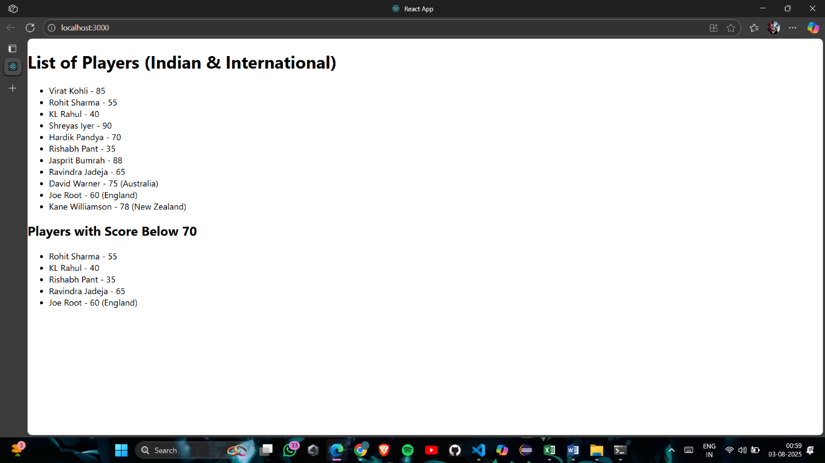

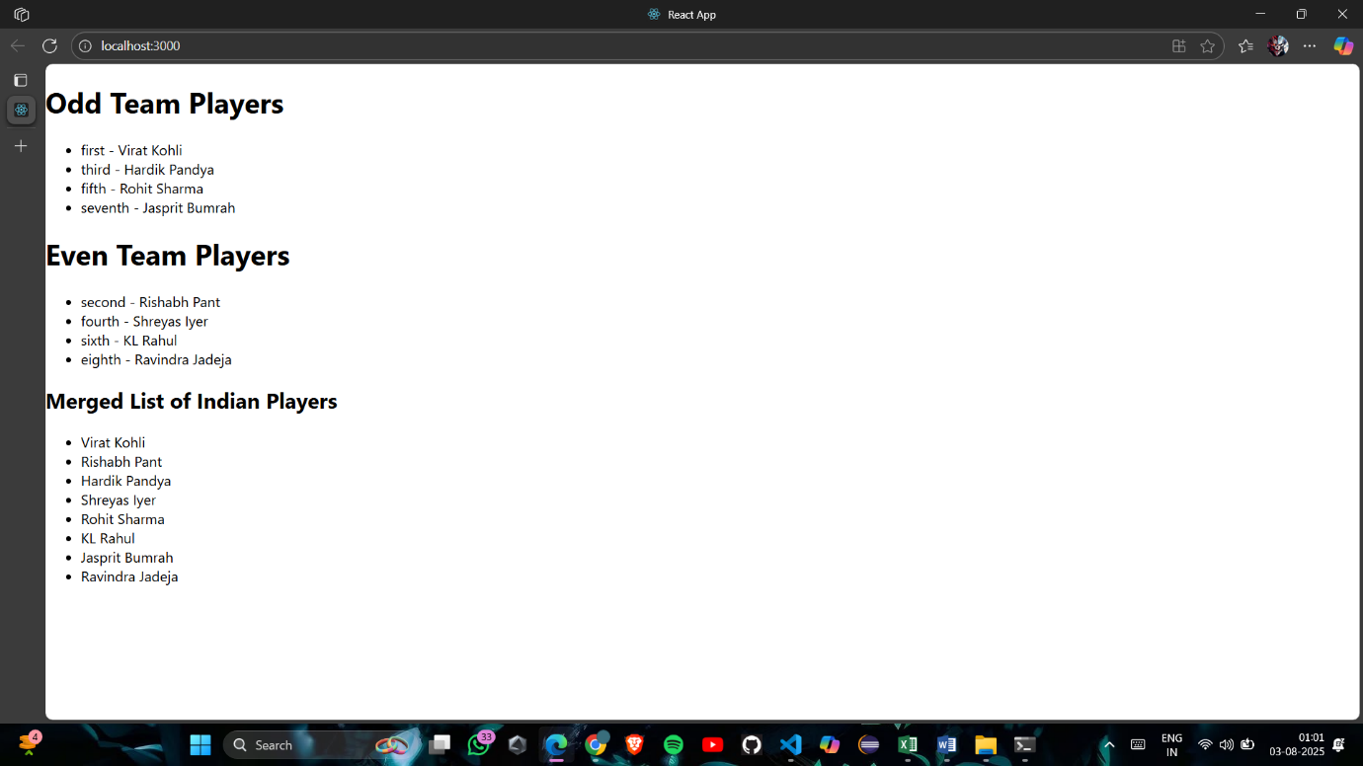Output when flag = false;

## **2. Hands-On2: (officespacerentalapp)**

**FILENAME: App.js**

***import*** React ***from*** 'react';

***function*** App() {

***const*** featuredOffice ***=*** {

    name: "PBS",

    rent: *75000*,

    address: "MG Road, Bengaluru",

    image: "https://www.gharjunction.com/img/blog/36.jpg"

  };

***const*** offices ***=*** [

    {

      name: "WeWork",

      rent: *55000*,

      address: "Indiranagar, Bengaluru",

      image: "https://encrypted-tbn0.gstatic.com/images?q=tbn:ANd9GcTm66f36J95Us1b34jN7pciEk2bP25NMxdxhQ&s"

    },

    {

      name: "Regus",

      rent: *65000*,

      address: "Koramangala, Bengaluru",

      image: "https://media.glassdoor.com/lst2x/7c/a5/45/ec/timesjobs-com.jpg?signature=7a70d46d0f27719eea42f32f2fdd8ded1d20fc32b7b37a317332e19051f58871"

    }

  ];

***const*** getRentStyle ***=*** (rent) ***=>*** ({

    color: rent ***<*** *60000* ***?*** 'red' ***:*** 'green',

    fontWeight: 'bold'

  });

***const*** pageStyle ***=*** {

    fontFamily: 'Segoe UI, sans-serif',

    backgroundColor: '#f2f4f8',

    padding: '30px',

    textAlign: 'center'

  };

***const*** containerStyle ***=*** {

    maxWidth: '900px',

    margin: '0 auto'

  };

***const*** headingStyle ***=*** {

    fontSize: '36px',

    marginBottom: '30px',

    color: '#2c3e50'

  };

***const*** cardStyle ***=*** {

    backgroundColor: '#fff',

    padding: '20px',

    borderRadius: '10px',

    boxShadow: '0 2px 8px rgba(0,0,0,0.1)',

    marginBottom: '20px',

    textAlign: 'left'

  };

***const*** imageStyle ***=*** {

    width: '100%',

    height: 'auto',

    borderRadius: '8px'

  };

***const*** officeListStyle ***=*** {

    display: 'grid',

    gridTemplateColumns: '1fr 1fr',

    gap: '20px',

    marginTop: '20px'

  };

***return*** (

    <div style***=***{pageStyle}>

      <div style***=***{containerStyle}>

        <h1 style***=***{headingStyle}> Office Space Rental App</h1>

        <div style***=***{cardStyle}>

          <h2>Office Space, at Affordable range</h2>

          <img src***=***{featuredOffice.image} alt***=***"Office Space, at Affordable range" style***=***{imageStyle} />

          <h3><strong>Name:</strong> {featuredOffice.name}</h3>

          <p><strong>Address:</strong> {featuredOffice.address}</p>

          <p><strong>Rent:</strong> <span style***=***{getRentStyle(featuredOffice.rent)}>₹{featuredOffice.rent}</span></p>

        </div>

        <h2>Other Office Listings</h2>

        <div style***=***{officeListStyle}>

          {offices.map((office, index) ***=>*** (

            <div key***=***{index} style***=***{cardStyle}>

              <img src***=***{office.image} alt***=***{office.name} style***=***{imageStyle} />

              <p><strong>Name:</strong> {office.name}</p>

              <p><strong>Address:</strong> {office.address}</p>

              <p><strong>Rent:</strong> <span style***=***{getRentStyle(office.rent)}>₹{office.rent}</span></p>

            </div>

          ))}

        </div>

      </div>

    </div>

  );

}

***export*** ***default*** App;

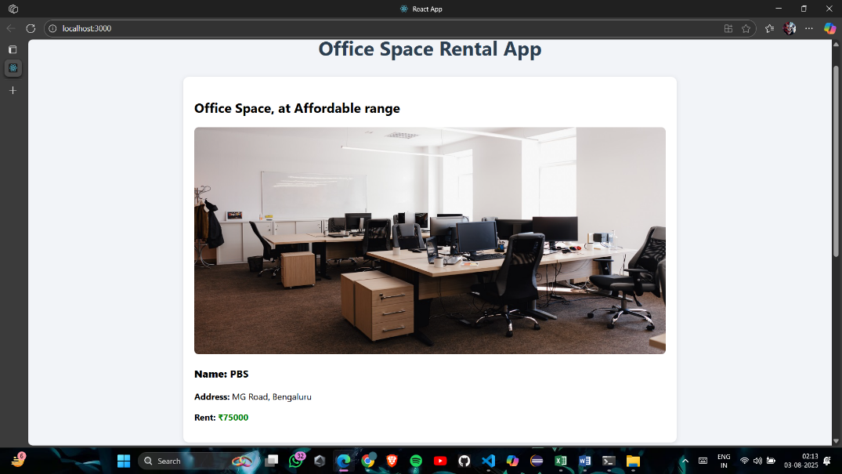**Output:**

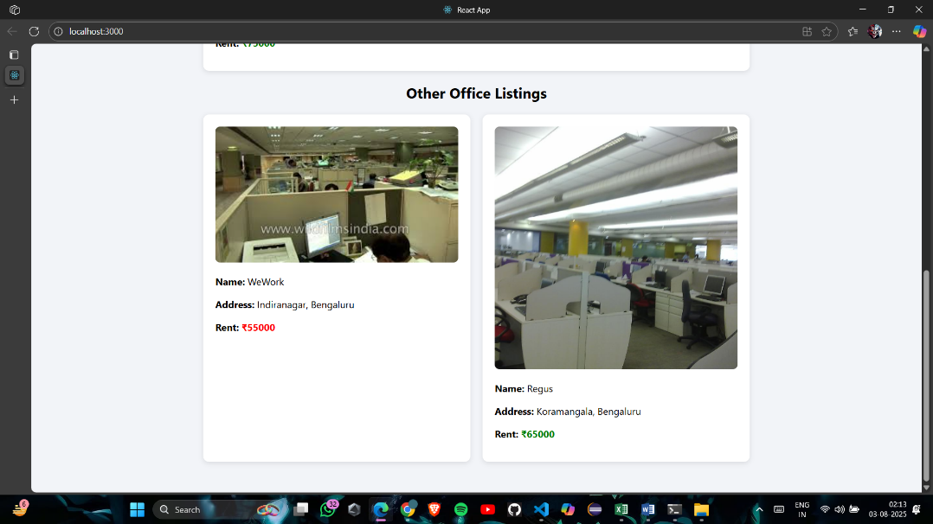

## **3. Hands-On3: (eventexamplesapp)**

**FILENAME:App.js**

***import*** React, { Component } ***from*** 'react';

***import*** CurrencyConvertor ***from*** './CurrencyConvertor';

***class*** App **extends** Component {

***constructor***(props) {

    super(props);

*this*.state ***=*** {

      count: *5*

    };

  }

  increment ***=*** () ***=>*** {

*this*.setState({ count: *this*.state.count ***+*** *1* });

*this*.sayHello();

  };

  sayHello ***=*** () ***=>*** {

    alert("Hello! Member1");

  };

  decrement ***=*** () ***=>*** {

*this*.setState({ count: *this*.state.count ***-*** *1* });

  };

  sayWelcome ***=*** (message) ***=>*** {

    alert(`Say Welcome Message: ${message}`);

  };

  handleSyntheticEvent ***=*** (e) ***=>*** {

    e.preventDefault();

    alert("I was clicked");

  };

  render() {

***return*** (

      <div>

        <p>{*this*.state.count}</p>

        <button onClick***=***{*this*.increment}>Increment</button>

        <button onClick***=***{*this*.decrement}>Decrement</button>

        <br /><br />

        <button onClick***=***{() ***=>*** *this*.sayWelcome("welcome")}>Say welcome</button>

        <br /><br />

        <button onClick***=***{*this*.handleSyntheticEvent}>Click on me</button>

        <br /><br />

        <CurrencyConvertor />

      </div>

    );

  }

}

***export*** ***default*** App;

**FILENAME:CurrencyConvertor.js**

***import*** React, { Component } ***from*** 'react';

***class*** CurrencyConvertor **extends** Component {

***constructor***(props) {

    super(props);

*this*.state ***=*** {

      rupees: '',

      euro: ''

    };

  }

  handleChange ***=*** (e) ***=>*** {

*this*.setState({ rupees: e.target.value });

  };

  handleSubmit ***=*** (e) ***=>*** {

    e.preventDefault();

***const*** euroRate ***=*** *0.011*; *// 1 INR ≈ 0.011 Euro*

***const*** converted ***=*** (*this*.state.rupees ***\**** euroRate).toFixed(*2*);

*this*.setState({ euro: converted });

  };

  render() {

***return*** (

      <div>

        <h2>Currency Convertor!!!</h2>

        <form onSubmit***=***{*this*.handleSubmit}>

          <label>Amount:</label>

          <input

            type***=***"number"

            value***=***{*this*.state.rupees}

            onChange***=***{*this*.handleChange}

          />

          <br />

          <label>Currency:</label>

          <textarea value***=***{*this*.state.euro} readOnly />

          <br />

          <button type***=***"submit">Submit</button>

        </form>

      </div>

    );

  }

}

***export*** ***default*** CurrencyConvertor;

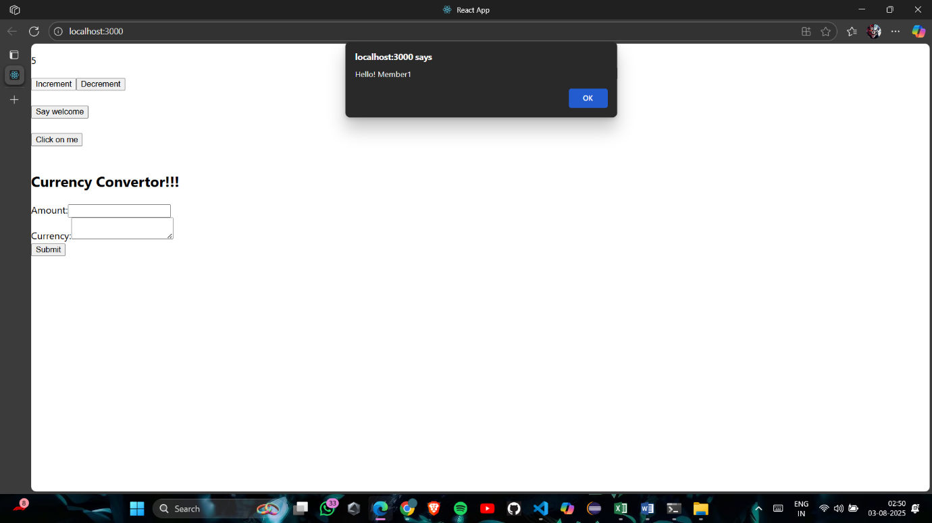**Output:**

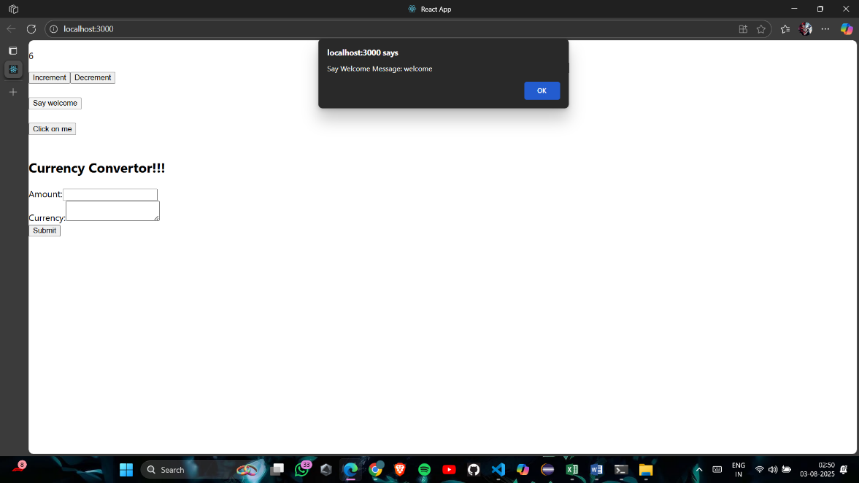

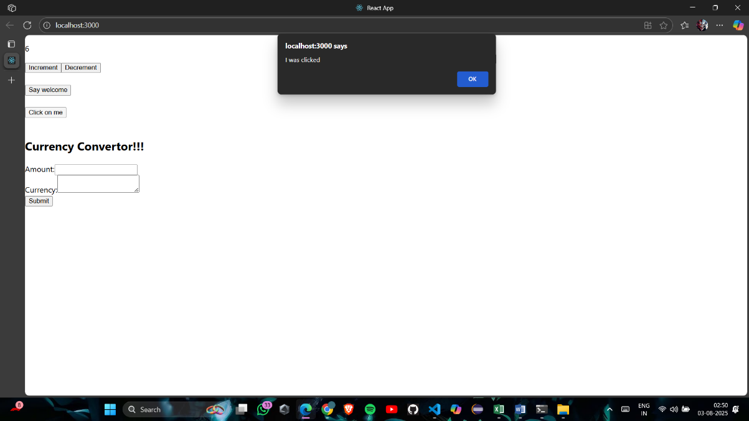

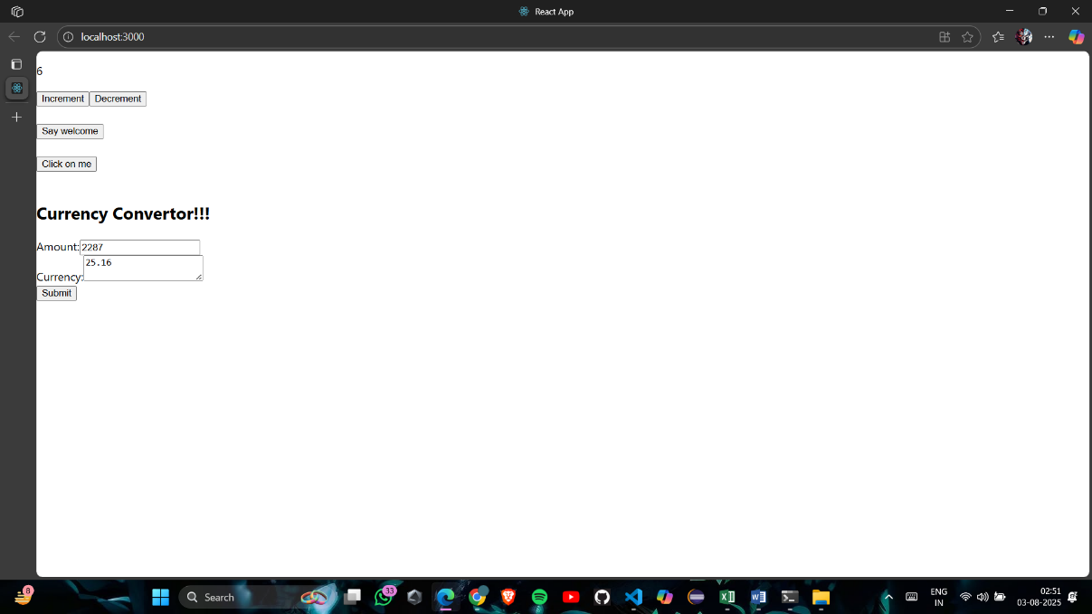

## **4. Hands-On4: (ticketbookingapp)**

**FILENAME:src/App/js**

***import*** React, { useState } ***from*** 'react';

***import*** GuestPage ***from*** './components/GuestPage';

***import*** UserPage ***from*** './components/UserPage';

***import*** FlightDetails ***from*** './components/FlightDetails';

***function*** App() {

***const*** [isLoggedIn, setIsLoggedIn] ***=*** useState(false);

***const*** toggleLogin ***=*** () ***=>*** setIsLoggedIn(***!***isLoggedIn);

***return*** (

    <div style***=***{{ padding: '20px', fontFamily: 'Arial' }}>

      <h1>Ticket Booking App</h1>

      <FlightDetails />

      {isLoggedIn ***?*** <UserPage /> ***:*** <GuestPage />}

      <button onClick***=***{toggleLogin} style***=***{{ marginTop: '20px' }}>

        {isLoggedIn ***?*** 'Logout' ***:*** 'Login'}

      </button>

    </div>

  );

}

***export*** ***default*** App;

**FILENAME:src/components/GuestPage.js**

***import*** React ***from*** 'react';

***const*** GuestPage ***=*** () ***=>*** {

***return*** (

    <div>

      <h3>Guest View</h3>

      <p>Please login to book your tickets.</p>

    </div>

  );

};

***export*** ***default*** GuestPage;

**FILENAME: src/components/UserPage.js**

***import*** React ***from*** 'react';

***const*** UserPage ***=*** () ***=>*** {

***return*** (

    <div>

      <h3>User View</h3>

      <p>You are now logged in. You can book tickets.</p>

      <button>Book Ticket</button>

    </div>

  );

};

***export*** ***default*** UserPage;

**FILENAME: src/components/FlightDetails.js**

***import*** React ***from*** 'react';

***const*** FlightDetails ***=*** () ***=>*** {

***return*** (

    <div>

      <h2>Available Flights</h2>

      <ul>

        <li>Delhi to Mumbai </li>

        <li>Mumbai to Chennai </li>

        <li>Chennai to Delhi </li>

      </ul>

    </div>

  );

};

***export*** ***default*** FlightDetails;

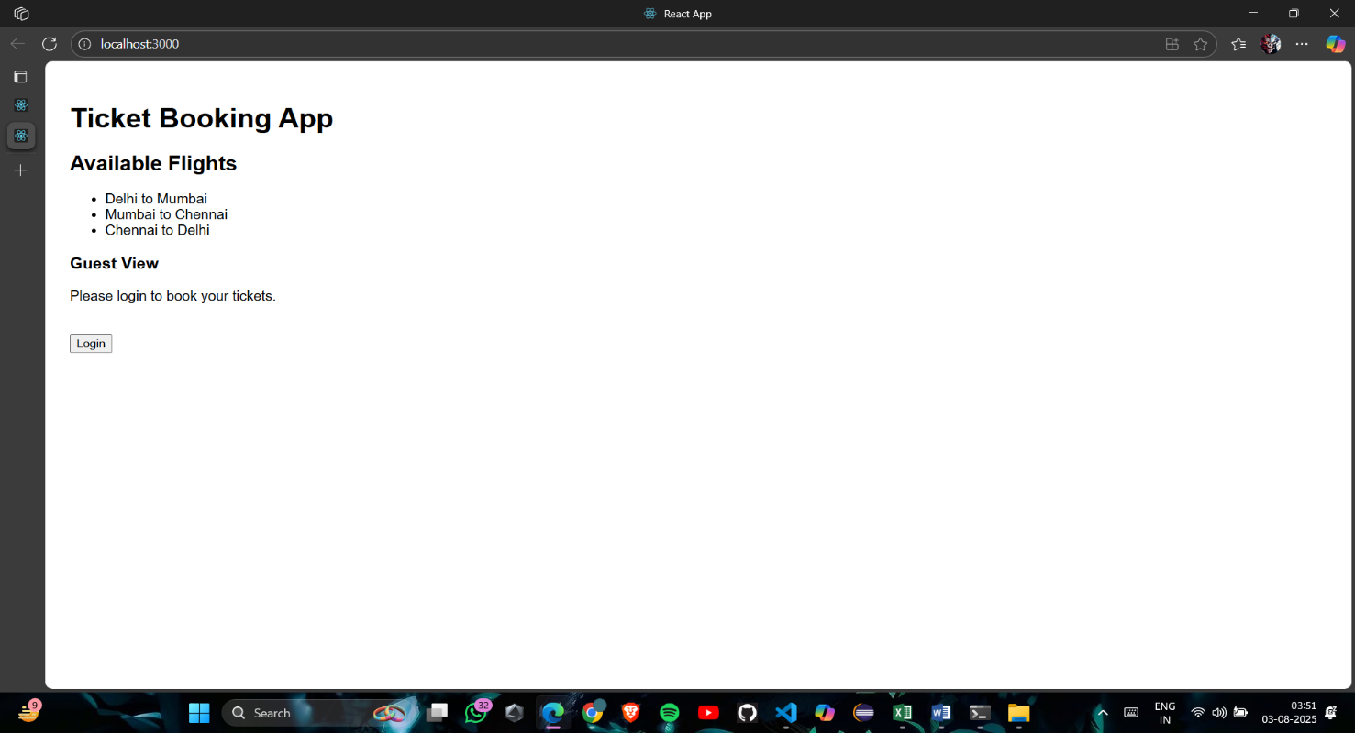**Output:**

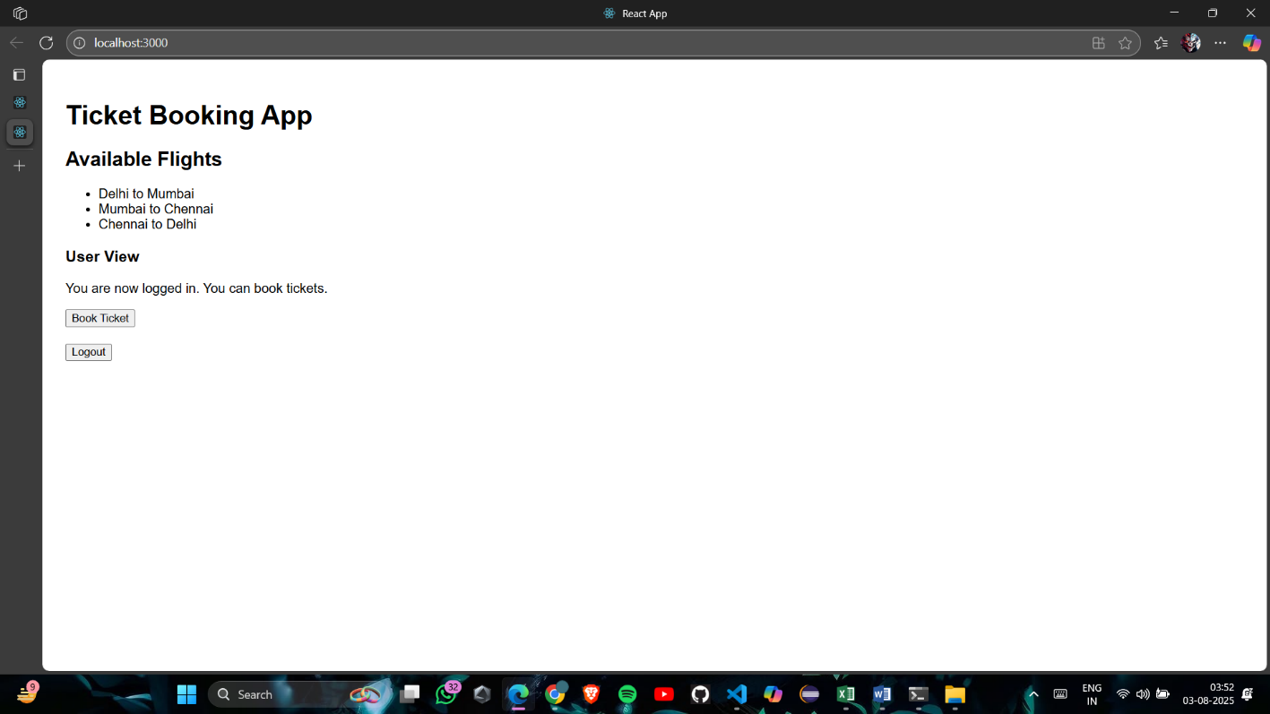

# **5. Hands-On5: (bloggerapp)**

**FILENAME: App.js**

***import*** React ***from*** 'react';

***import*** './App.css';

***function*** App() {

***const*** courses ***=*** [

    { name: "Angular", date: "4/5/2021" },

    { name: "React", date: "6/3/20201" }

  ];

***const*** books ***=*** [

    { title: "Master React", price: *670* },

    { title: "Deep Dive into Angular 11", price: *800* },

    { title: "Mongo Essentials", price: *450* }

  ];

***const*** blogs ***=*** [

    { title: "React Learning", author: "Stephen Biz", content: "Welcome to learning React!" },

    { title: "Installation", author: "Schewzdenier", content: "You can install React from npm." }

  ];

***return*** (

    <div className***=***"container">

      <div className***=***"column">

        <h2>Course Details</h2>

        {courses.map((c, i) ***=>*** (

          <div key***=***{i}>

            <strong>{c.name}</strong>

            <p>{c.date}</p>

          </div>

        ))}

      </div>

      <div className***=***"column border-left">

        <h2>Book Details</h2>

        {books.map((b, i) ***=>*** (

          <div key***=***{i}>

            <strong>{b.title}</strong>

            <p>{b.price}</p>

          </div>

        ))}

      </div>

      <div className***=***"column border-left">

        <h2>Blog Details</h2>

        {blogs.map((b, i) ***=>*** (

          <div key***=***{i}>

            <strong>{b.title}</strong>

            <p><b>{b.author}</b></p>

            <p>{b.content}</p>

          </div>

        ))}

      </div>

    </div>

  );

}

***export*** ***default*** App;

**FILENAME:BookDetails.js**

***const*** BookDetails ***=*** () ***=>*** {

***return*** (

    <div>

      <h2>Book Details</h2>

      <p>Title: React for Beginners</p>

      <p>Author: Jane Doe</p>

    </div>

  );

};

***export*** ***default*** BookDetails;

**FILENAME: BlogDetails.js**

***const*** BlogDetails ***=*** () ***=>*** {

***return*** (

    <div>

      <h2>Blog Details</h2>

      <p>Title: Why React is Awesome</p>

      <p>Author: John Smith</p>

    </div>

  );

};

***export*** ***default*** BlogDetails;

**FILENAME:CourseDetails.js**

***const*** CourseDetails ***=*** () ***=>*** {

***return*** (

    <div>

      <h2>Course Details</h2>

      <p>Course: Fullstack with React</p>

<p>Instructor: Mary Poppins</p>

    </div>

  );

};

***export*** ***default*** CourseDetails;

**Output:**

